Data Preparation and Evaluation
We developed eight synthetic classification problems to check the behavior of our support vector machine (SVM) and selected four external datasets to evaluate it on distinct prediction tasks. For the synthetic problems, we know the rule that generated each label, so we can compare the fitted boundary with the underlying geometry. Each external task uses a separate SVM fit.

Synthetic data design
We drew candidate feature vectors x = (x₁, x₂) uniformly from [−2, 2]² and assigned labels in {−1, +1}. Each problem contains 300 training, 100 validation, and 100 test observations, drawn separately using distinct deterministic seeds. Keeping the input in two dimensions lets us inspect the margin, support vectors, and disagreements between the fitted and generating boundaries.
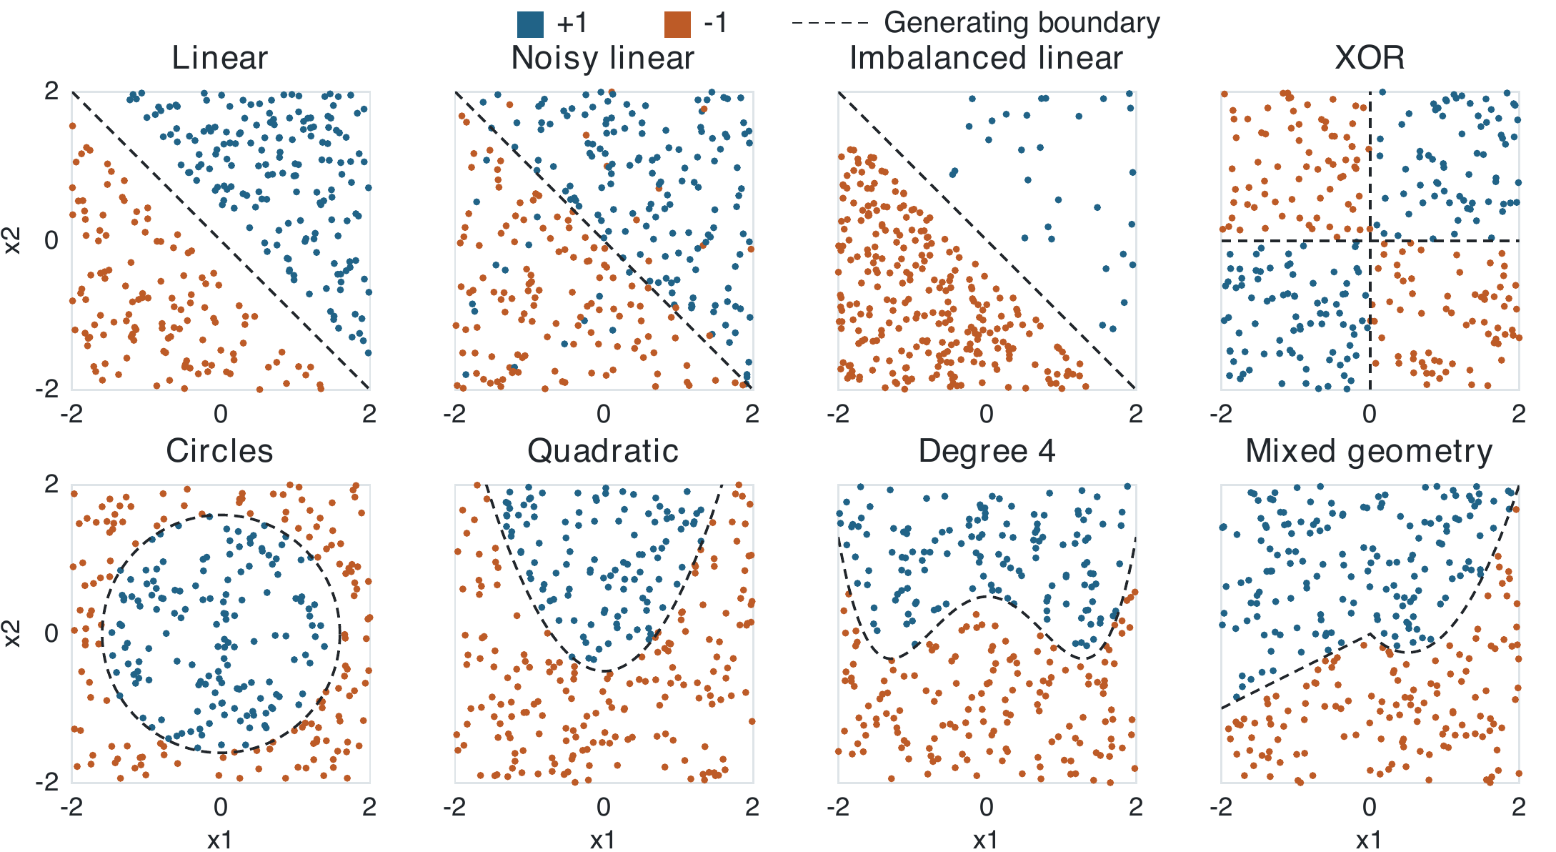
Figure 1. The eight synthetic training sets. Each panel shows 300 observations, with a dashed line marking the generating boundary. In the noisy linear case, some observed labels disagree with that boundary by design.
The linear case omits points with |x₁ + x₂| < 0.4, creating a gap around the separator. The noisy version keeps those points and independently flips each label with probability 0.10. These changes create examples for examining the soft-margin penalty C. The imbalanced version retains the clean gap and fixes the positive class at 10% of each split. A majority-class prediction therefore gives 90% accuracy and zero positive-class recall.
The circle and XOR rules depend on x₁² + x₂² and x₁x₂, respectively, so both boundaries can be represented with quadratic features. The parabola and degree-4 curve, x₂ = 0.3x₁⁴ − x₁² + 0.5, extend this comparison across polynomial degrees. In the mixed case, the line x₂ = 0.5x₁ for x₁ < 0 meets the parabola x₂ = x₁² − x₁ at the origin. This case tests how one decision function fits a boundary whose shape varies by region.
The generator uses base seed 582 and saves the splits as CSV files. The metadata file at data/synthetic/metadata.json records the generating rules, split seeds, and class counts.

External datasets
The external datasets vary in size, feature type, and class balance. Table 1 lists the local row counts. Figure 2 shows the class proportions before any splitting or subsampling.
Table 1. External datasets and prediction targets.
Dataset and source | Rows | Target and features
Student Pass/Fail | 100 | Pass / fail. Four predictors including attendance and midterm score.
Wisconsin Breast Cancer | 569 | Malignant / benign. Thirty measurements from cell images.
Loan Approval | 45,000 | Loan status. Numerical and categorical applicant and loan features.
Banknote Authentication | 1,372 | Forged / genuine. Variance, skewness, kurtosis, and entropy.
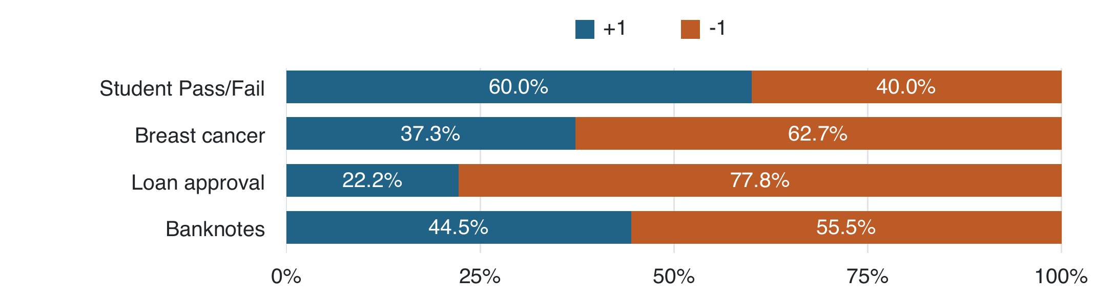
Figure 2. Class proportions in the project CSVs. The positive class denotes pass, malignant, positive loan status, and forged, respectively.

Training and testing protocol
For each dataset, separate the target from the predictors and exclude record identifiers. Encode 0 as −1 and 1 as +1. For breast cancer, the original labels B (benign) and M (malignant) correspond to −1 and +1. The prepared loan file uses integer codes for categorical predictors. For an unordered feature such as loan purpose, these codes can impose artificial distances in the kernel.
Use the supplied synthetic splits and create reproducible, stratified splits for the external datasets where feasible. Fit scaling on the training features and apply those same parameters to validation and test data. Compare kernels, optimizer settings, and values of C, polynomial degree, or RBF bandwidth on fixed splits. Select the configuration on validation data and reserve the test set for final evaluation.
Report a confusion matrix alongside accuracy and include balanced accuracy and class-specific recall when class proportions differ. Record the training sample size if subsampling the loan data. A dense dual SVM forms an n × n kernel matrix for n training examples, so memory grows quadratically with sample size.

